AI-Powered Personalized Learning Path Recommender
Architecture Proposal — HCL Amplified Challenge

1. Problem Statement
Online learning platforms offer thousands of courses across diverse domains. While recommendation systems can suggest relevant courses, learners often struggle to identify the right sequence of learning resources needed to achieve a specific goal.
Different learners have different skill levels, interests, career aspirations, and learning preferences, making a one-size-fits-all approach ineffective. An AI-powered Personalized Learning Path Recommender can bridge this gap by understanding a learner's profile, analyzing learning objectives, identifying skill gaps, and generating a structured roadmap of courses, projects, and assessments tailored to the individual.

Task
Design and build an intelligent learning assistant that recommends personalized learning paths based on a learner's interests, goals, previous learning history, and skill level. The solution must generate a structured learning roadmap, explain recommendations, and adapt suggestions based on user feedback and progress.

2. Expected Solution — As Per the Problem Statement
The problem statement asks for six concrete deliverables:
- Conversational interface — a natural-language front end where learners describe their goals in their own words.
- Learner profiling engine — captures interests, experience level, completed courses, and objectives.
- Recommendation engine — suggests relevant courses, projects, and learning resources.
- Personalized learning path generator — sequences resources with prerequisites and milestones, not a flat ranked list.
- Explainability assistant — explains why each recommendation was made and answers learner queries.
- Progress dashboard — visualizes skill development, milestones, and next recommended actions.

3. What We Are Proposing
Rather than building a single large model, we propose a system that combines several small, individually evidence-backed techniques — each one chosen because a naive or single-method alternative has a documented failure mode in the research and reference implementations we reviewed. The guiding principle: use an LLM only where language reasoning is genuinely required (goal understanding, explanation), and use deterministic algorithms everywhere accuracy and reproducibility matter more (skill matching, sequencing, retrieval).
Concretely, we propose:
- Chain-of-Thought goal decomposition (pattern from GenMentor, WWW 2025) instead of single-shot goal-to-skill prompting.
- An EduCOR-inspired data schema (Skill → Knowledge Topic → Resource) instead of a flat course table, so one resource can serve multiple skill goals.
- Hybrid keyword + semantic retrieval for the recommendation engine, instead of a single retrieval method.
- A* search over a prerequisite graph for path sequencing, instead of asking an LLM to order resources directly.
- A dual-graph reroute mechanism (prerequisite graph + similarity graph, pattern from DLELP / KnowLP) so a learner who gets stuck is rerouted through a related concept instead of the path dead-ending.
- A single lightweight validator pass (pattern from GenMentor) that checks pacing and difficulty before a path is shown.
- A score-grounded explainer (pattern from KnowPath) that phrases real retrieval and skill-gap numbers into language, rather than letting an LLM invent a justification.

4. Our Architecture
The diagram below maps every architectural component directly onto one of the six problem-statement deliverables, so there is no ambiguity about what satisfies which requirement.

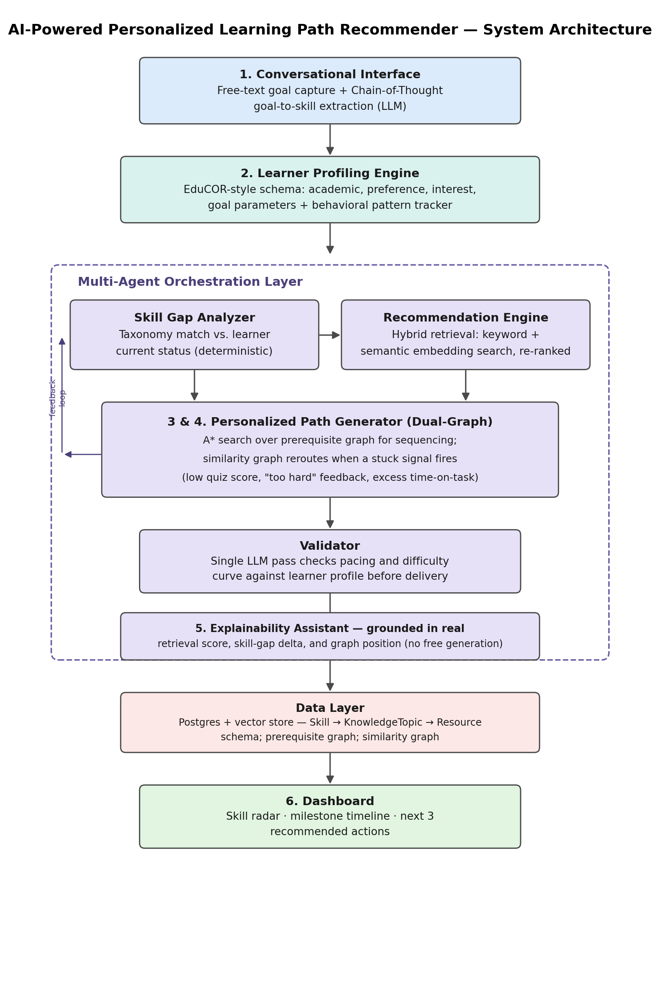
Figure 1 — System architecture, mapped to the six PS deliverables.

5. Workflow
The sequence below traces one full learner session end-to-end, including the adaptive reroute path that fires when a learner gets stuck on a topic — this single loop demonstrates the profiling, path-generation, explainability, and dashboard requirements together.
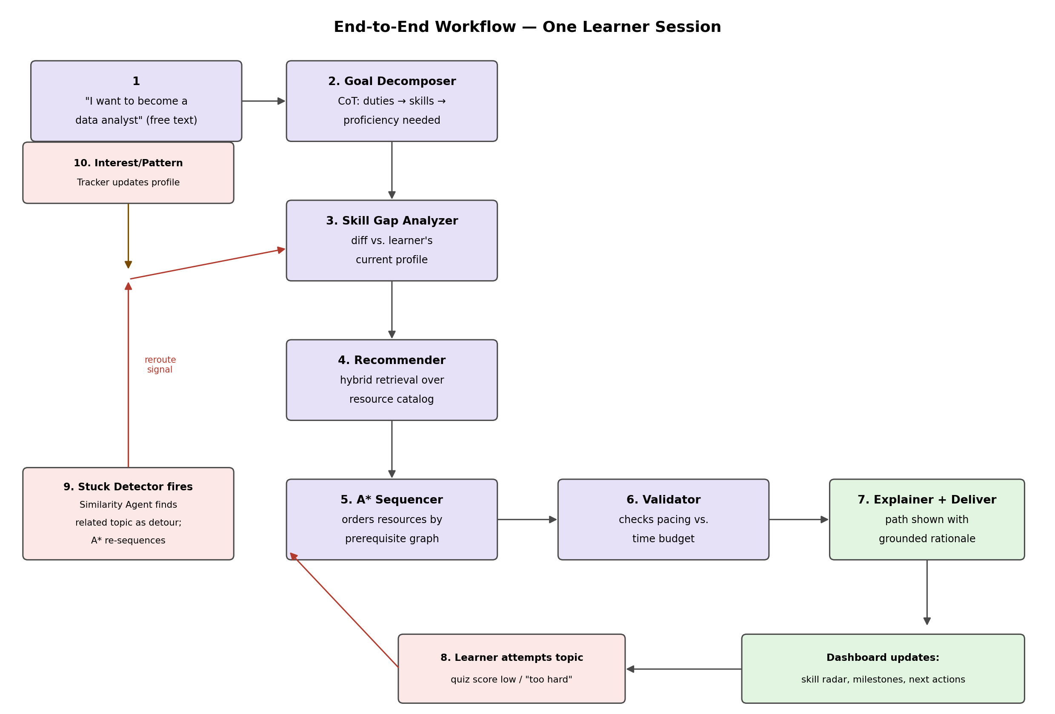
Figure 2 — End-to-end workflow for one learner session, including the stuck-detector reroute loop.

6. Resources Referenced
The following repositories, papers, and write-ups were reviewed during the design process; the specific pattern taken from each is noted.

Repositories
- GenMentor — goal decomposition, learner-simulator validation pattern — https://github.com/GeminiLight/gen-mentor
- CAHLR/goal-based-recommendation — prerequisite inference from performance data — https://github.com/CAHLR/goal-based-recommendation
- tibonto/educor — Skill → KnowledgeTopic → Resource ontology schema — https://github.com/tibonto/educor
- Pxplore (pxplore-algo) — 4D learner state framing (goal, motivation) — https://github.com/Pxplore/pxplore-algo
- sinsniwal/PathPilot-recommendation-system — relational schema and REST API surface reference — https://github.com/sinsniwal/PathPilot-recommendation-system
- mjpriyanshu/Learnit — transparent weighted-scoring pattern for explainability fallback — https://github.com/mjpriyanshu/Learnit

Research Papers
- GenMentor (arXiv 2501.15749, WWW 2025) — goal-oriented tutoring with CoT skill mapping — https://arxiv.org/pdf/2501.15749
- KnowPath (ACM TOIS, 2026) — LLM-supported knowledge graph + path finding for explainable MOOC recommendation — https://dl.acm.org/doi/10.1145/3779436
- DLELP / KnowLP (arXiv 2506.22303) — dual-graph (prerequisite + similarity) learning path recommendation — https://arxiv.org/abs/2506.22303
- Personalized Learning Path Recommendation Based on Knowledge Graphs — Survey (MDPI) — https://www.mdpi.com/2079-9292/15/1/238
- An adaptable and personalized framework for top-N course recommendations (Scientific Reports, Nature, 2024) — https://www.nature.com/articles/s41598-024-56497-1

Other Resources
- Coursera Personalized Learning Path — UX case study of a real production feature — http://www.ewdsgn.com/coursera-plp
- ESCO — European skills/occupations taxonomy, candidate source for the skill graph — https://esco.ec.europa.eu/en/use-esco/download

7. How This Compares to Existing Approaches
Each design choice below was made because a simpler alternative has a documented weakness — either from published ablation results in the papers we reviewed, or from a concrete failure we found while auditing reference repositories.
Component | Naive / common approach | What we propose | Evidence for the change
Goal understanding | Single-shot LLM prompt: “what skills does this goal need?” | Chain-of-Thought structured extraction (duties → skills → proficiency) | GenMentor: Recall 0.42 (direct prompt) → 0.67 (CoT, fine-tuned); CoT structure alone recovers most of this gap
Path sequencing | Ask an LLM to order the resource list directly | A* search over an explicit prerequisite graph | GenMentor's own ablation: direct-prompt scheduling scores 3.95/5 Progression vs. 4.56/5 for their refined, structure-assisted version
Handling a stuck learner | Fixed prerequisite chain with no fallback — the path dead-ends | Dual graph: prerequisite graph + similarity graph, with a stuck-detector and reroute agent | DLELP / KnowLP: motivated explicitly by “learning blockage” in single-graph systems
Recommendation retrieval | random.sample() over hardcoded tiers, or unlabeled user-user KNN mislabeled as “collaborative filtering” | Hybrid keyword + semantic embedding retrieval, re-ranked | Found in direct code audit of PathPilot and chrisamz reference repos — both “AI” recommenders were non-functional as ML
Explanation generation | LLM freely reasons about why a resource fits | LLM phrases the real retrieval score, skill-gap delta, and graph position | KnowPath: motivated by same-titled courses needing differentiated, non-hallucinated explanations
Data schema | Flat course table; skill mapped directly to a single course | Skill → Knowledge Topic → Resource mediation layer | EduCOR: over 83% Recall retrieving resources across multiple external repositories using this schema shape

Net effect
No component in this architecture requires model training, fine-tuning, or reinforcement learning — every efficiency gain above comes from a structural or algorithmic choice, not a heavier model. This keeps the system buildable within a five-day timeline while giving a specific, citable justification for every accuracy claim made in the final submission, rather than an unverified “we used an LLM” claim.

